Lab 4
In this lab, you’ll continue working on the program you wrote in lab 2. The starter code, provided on Canvas, has the classes Cat and AnimalShelter, and code to create an empty window using pygame.

Step 0
- Open the lab4.py starter code. For this lab, do not split your code into different files – keep everything in one file (lab4.py).
- Do not make changes to the classes Cat and AnimalShelter.
- An object of the class AnimalShelter is being created in your main program. One cat is already being added (Garfield). You may leave this code as-is.
- You will no longer have a menu of choices (add pet, display pet, …) printed to the shell, like you did in lab 2. Instead you will have a GUI form where you'll enter the data for a new cat.
- The form will have an "Add" button and a "Show all cats" button.

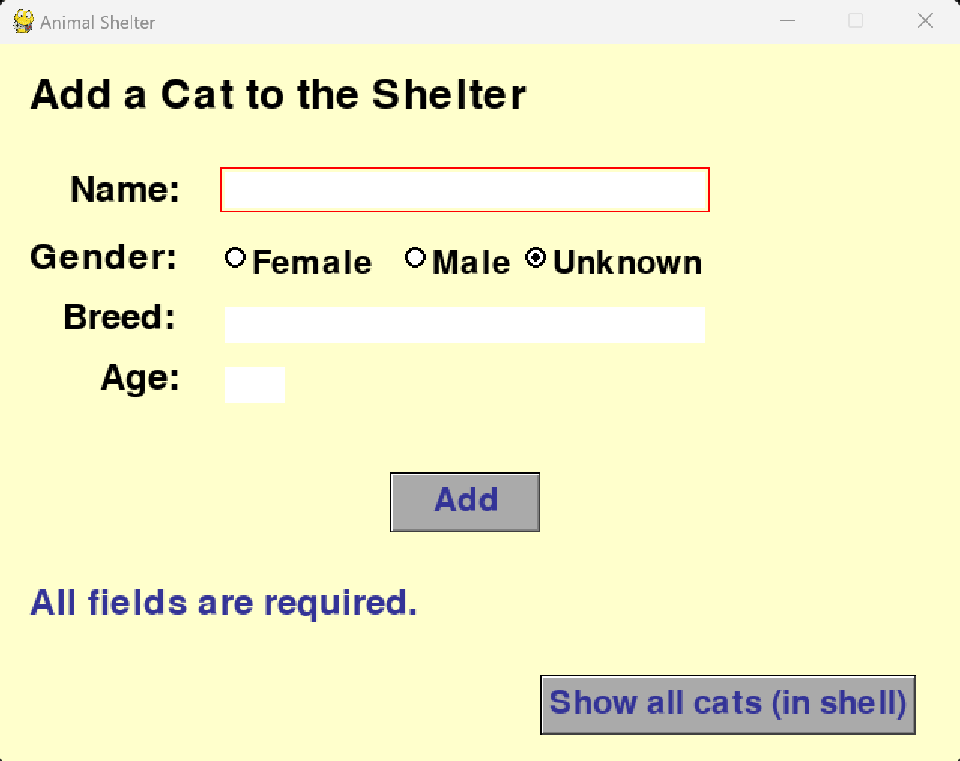

Step 1

UI Elements
- Add all UI elements to the window seen in the above image.
  - Give initial focus to the Name text box.
  - Whenever any input text box has focus, make the outline of the rectangle red (or another color). The outline makes the focus more visible than just the blinking cursor.
  - Make "unknown" the default radio button (selected on load).
  - Change the text size/color for the Add and Show All Cats buttons, to make them more readable than the default font.
  - The initial status message must say "All fields are required."
- Hints:
  - You'll need to use the following pygwidgets classes: DisplayText(), InputText(), TextRadioButton(), and TextButton().
  - Usage details for the pygwidgets classes can be found in the documentation:
    - https://pygwidgets.readthedocs.io/en/latest/
  - Some of the requirements above are very simple to add – check the documentation.
- You may choose your own colors and widget placement.

Step 2

The "Add" Button
- When the user clicks the "Add" button, the program must check that all fields have data. It must also check that the age is an integer.
- If any field is missing/incorrect, the status message must change to an error message.
  - The error message must be specific, for example: Name is required, or Breed is required, or Age must be an integer. Do not use the same message for all errors.
  - The error message should not have the same color as a non-error status message. Red is a good color for error messages, as long as it stays visible on the background.
  - The program should not attempt to add the pet to the shelter with missing or incorrect data.
  - Do not clear the form data when an error message is displayed – the user should be able to correct only the needed fields, without having to re-enter everything.
- If all fields are okay, call oAnimalShelter.add() passing the data entered by the user to add a new pet to the shelter.
  - The status message should display the added pet's name and ID. This status message should not have the same color as the error messages.
  - Now, the text fields should be cleared, in preparation for the next cat. The radio button does not need to be reset to "unknown" (but it's okay if you choose to reset it).

Step 3

The "Show All Pets" Button
- Call oAnimalShelter.display_all() to display information for all pets in the python shell (not in the GUI window).
  - This will allow you to verify that the Add button is correctly adding the pets to the shelter.

Step 4

Submit your program on Canvas.
- All code should be in the same file, named lab4.py
- Don’t forget to test your code and add comments.

